High Speed Wireless Data Transmission Using
Li-Fi for Android Mobile
Mr Narhari R. Kotkar , Mr. Chankya Kumar Jha erchankya@gmail.com

Abstract—Nowadays the audio video data transmission between two android phones takes time. This paper gives the design of system full-duplex wireless visible light communication (VLC) system based on Light fidelity (Li-Fi) which transmit data bidirectional simultaneously by using LED as transmitter and Si PIN (Hamamatsu S6968) photodiode as receiver between two android mobile. This system develops a prototype to demonstrate a bidirectional wireless communication system based on Android Mobile. In this system, two android mobiles phones can transmit local data stored in the memory of mobile to each other anyone mobile either act as a transmitter or receiver. The system consists of two parts mainly one is hardware and other software. The hardware design is based on the USB port integrated to Android Mobile. The development of software utilizes the protocol of AOA (Android Open Accessory) which is a new feature in Android 3.1 or more advanced version by connecting external USB bridge which allowing data transmission between Android devices over USB interfaces. Combing with a USB port on one board, it can achieve up to 3Mbps bit rates error free, which is mainly limited to the USB bridge circuit between two mobiles for data transmission such as text, audio and video. This paper also shows the experimental results and the relationship between system transmission eye diagram and bit rate.

Index Terms—Visible Light Communications ,LED diodes; Android Mobile; USB interface; AOA; Full-duplex; Real-time Transmission.

INTRODUCTION
The traditional wireless communication technologies between mobile phones are Bluetooth and IrDA Wi-Fi as well. They cannot provide a directional wireless channel for two phones. This paper attempts to build a new transport by which the mobile terminals can transfer local data to each other simultaneously.
The technology was demonstrated at the 2012 Consumer Electronics Show in Las Vegas using a pair of Casio smart phones to exchange data using light of varying intensity given off from their screens, detectable at a distance of up to ten meters .Haas has set up a spin-off firm to sell a consumer VLC transmitter that is due for launch next year. It is capable of transmitting data at 100 MB/s - faster than most UK broadband connections [1], [2], [3], [4], [5], [6], [7], [8], [9], [10], [11], [12].

In this paper, a new transport by which the mobile terminal can transfer data to each other is designed as a basic application of visible light communication on mobile terminals. Self-written software is used to send and receive the stream of data between two Android mobiles. Accordingly part II give information regarding system design part III gives block and circuit diagram implementation, part IV give result of implemented system , part V gives conclusion and future related to designed prototype

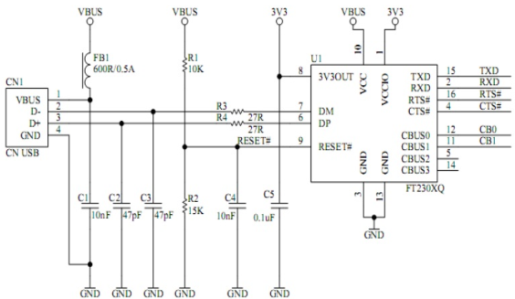

Fig. 2 : FT230XB Circuit Schematic
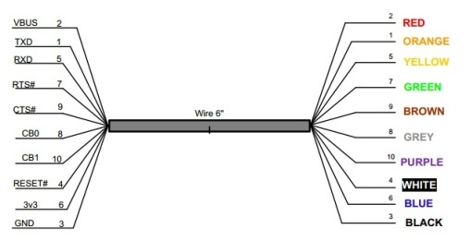
Fig.3 : FT230XB Wire Connections

.

Si PIN (Hamamatsu S6968) photodiode
The photo detector used for optical to electrical Conversion with 150 mm² effective active area, 14mm active area size and 35° half angle. Fig. 4 shows directivity curve for Si PIN (Hamamatsu S6968) photodiode.
Directivity
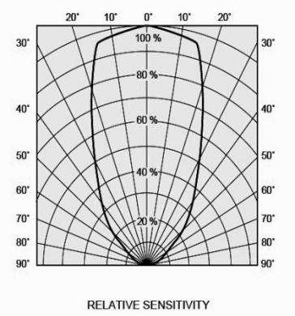
Fig. 4 : Directivity curve

LED (Light Emitting Diode)
A high power white light LED of 300mW and with the beam angel 120° is used as the optical transmission source.

Fig.5: Receiver circuit diagram.

BLOCK Diagram and Circuit Diagram
The receiver employs a commercially available photo detector Si PIN (Hamamatsu S6968) photodiode receives optical signal which is sent to a low pass filter followed by a custom amplifier for recovery then decision circuit (LT1715) issued as a single threshold voltage comparator to achieve the signal decision with a reference voltage level to obtain the original signal after that FT230XB achieve the conversion from TTL signal to USB serial signal. Fig.5 shows the implementation of receiver circuit diagram.
Similarly at transmitter side FT230 will realize the conversion of signal of USB from differential to TTL. Then a voltage follower connected to the output pin of FT230 pull up the signal current to an adequate level, driving LED for lighting. A high power white light LED of 300mW and with the beam angel 120° is used as the optical transmission source. OOK NRZ data for Intensity modulation (IM) and direct detection (DD) scheme is chosen for the widely reception in VLC research. Fig.6 shows the implementation of transmitter circuit diagram.

Fig.6: Transmitter circuit diagram.

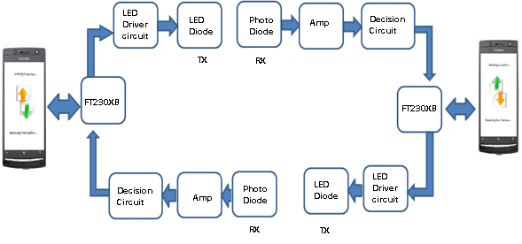

Fig.7: Transceiver block diagram.

The implementation of overall block diagram of transceiver circuit is given in Fig.7. The diagram gives signal flow for data communication take place between two android mobile.

Fig. 8: Testing Circuit for Designed circuit

The system is tested using the configuration shown in Figure 8, as the arbitrary waveform generator and oscilloscope instead of by using android mobile phone. Figure 9 presents the eye diagrams for the receiver arbitrary OOK NRZ data at speeds of 2 Mbps and 3 Mbps after optical signal conversation. The eye diagrams of the signal receive without amplify and filtering are clear, thus show error free performance. The eye diagrams indicate that the signal can be correct recovered after decision circuit [13], [14], [15], [16], [17].

Fig.9: Eye diagram waveforms after direct detection without filtering and being amplified at (a) 2 Mbit/s data rate, (b) 3 Mbit/s data rate.

We obtained the Q-factor of eye diagram at different transmission rates and estimated the BER from Q-factor . All BERs are below 10⁻⁶ when data rate goes up to 4.5 Mbit/s. The curve of Q-factor vs data rate is showed in Figure 10(a). We can find that the BER performance is mainly restricted to 3 dB bandwidth of the white LED emitter, where the normalized response is shown in Figure 10(b).

Fig.10: (a) Eye diagram Q-factor Vs data rate, (b) fre-quency response curves of the whit light LED.

The application used for this system is designed with the Eclipse Development Environment and Android and Java Development Environment Fig . 11 gives android development configuration required for the designing oh android application.

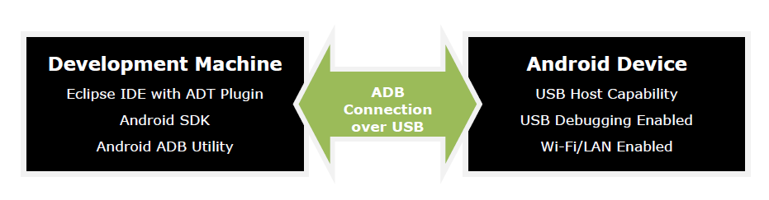
Fig. 11: Android Development Configuration

The development of the application utilizes the protocol of AOA (Android Open Accessory) which is a new feature whereby a USB host device can connect to the Android device to allow data transfer to and from the Android device over USB. Android supports USB host and accessory modes directly from the version of Android 3.1. USB accessory mode is also back ported to Android 2.3.4 as an add-on library to support a broader range of devices. Device manufacturers can choose whether or not to include the add-on library on the device's system image. The support of these modes of operation depends on the hardware of the device regardless of the platform level and it is structured in Fig.12.
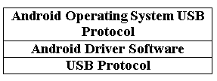

Fig.12 Functionality of the firmware for the Android USB accessory mode

The microcontroller firmware functionality will be conformed as shown in Fig. 12, to establish a data connection
between mobile devices that support USB accessory. The software application was developed using the example provided by FTDI Company. As it was stated before, the Eclipse Development Environment with the Android SDK and platform 3.1 or more advanced are used.
When the developed application is installed in the mobile phone, the software will detect the USB port once a module is plugged in, then it will read the Product ID and vector ID stored in the EEPROM as shown in Fig.13 of the FT230XB integrated in the module to determine whether the connector is enumerated and supported by the software through looking up the enumerated list integrated in the software in advance. The application can transfer the local data chosen by operator to the bit streams and send it to the USB port, such as text, audio, video and so on as shown in Fig.14 and Fig.15. The external module will transfer the signal from the USB and drive the LED. After a Line of sight channel, the opposite transceiver module plugged in the USB port of second mobile receives the bit streams and recovers the bit streams to the original data.
The developed application for data transmission also support to other types of FTDI D2xx family chip and according to device interfaced to mobile we set baud rate, data bit, parity and flow. Application able to transfer any type of file through the connected FT230XB connector to android mobile.

Fig. 13: Software screenshot which read Product ID and Vector ID of FT2030XB.

Fig. 14: Software Screenshot of UART data transmission.

- This application displays the functionality of UART.
- The first row contains an Open button to open selected Port numbers and a Config button to set UART configuration with several selectable setting items.
- The UART configuration settings allow the baud rate to be set at standard values between 300 and 921600 baud.
- Stop bits may be set for 1 or 2.
- Data bits may be set for 7 or 8.
- Parity may be set for ODD, EVEN, Mark, Space, None.
- Flow allows for no flow control, RTS/CTS, DTR/DSR and XOFF/XON flow control.
- The Read Bytes box displays the received data as ASCII values.
- The Read Enabled button is used to test stop/restart IN task APIs.
- Read Enabled will switch to Read Disabled when tapped, causing the application to stop receiving data.
- Tap it again to enable the receive functionality.
- Write Bytes allows a user to type in plain text and send it by tapping Write.

This application receives and sends data from and to Android device itself if a ‘FT230XB’ module is connected to mobile device.

Fig. 15: Software Screenshot for File Transmission.

RESULTS

With the system described above, performance of the USB module is measured. In the LED communication system, the optical power of the LED would be stronger and less susceptible to distance as the distance between the transmitter and receiver circuit goes on increasing. As input output waveform shown in fig. 16.

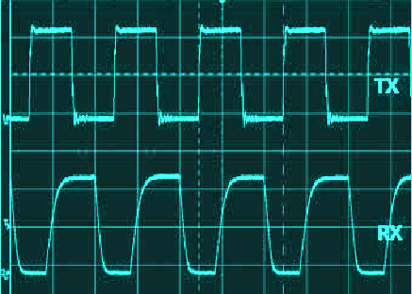

Fig. 16: Input output waveform of wireless communication system

By using this technology 3Mbps speed can be achieved using the wireless LED diode communication with the transmitter input as the green signal and the receiver output as the green signal. We can find there is a existence of time delay in this system. By comparing the signal waveform, It is clearly that there is little error bit after visible light transmission through the system. Although the signal that the receiver output is not the standard rectangular wave, the decision algorithm inside the controller board is able to detect errors in the data and provide correct error free output pattern.

CONCLUSION AND FUTURE WORK
In this paper, we developed a Half Duplex optical wireless system prototype to achieve the transmission between two android mobiles using the LED. The integration of an electronic device with the hardware and software of mobile devices for personal use was presented. This device is able to take advantage of the main features of mobile devices, allowing users to transmit the local data to each other like Bluetooth Wi-Fi. The upper limit transmission rate is 3 Mbit/s .The transmission bandwidth of the LED is very high. The proposed system use the USB 2.0 so the speed is limited to the USB protocol version and high speed communication can be achieved by using higher level protocol version of the USB. The obtained Q-factor of eye diagram at different transmission rates and estimated the BER from Q-factor. All BERs are below 10⁻⁶ when data rate goes up to 4.5 Mbit/s.
REFERENCES

- Komine T, Nakagawa M. Fundamental “analysis for visible-light communication system using LED lights”[J]. Consumer Electronics, IEEE Transactions on, 2004, 50(1): 100-107.
- VLCC, “Visible Light Communications Consortium,” 2008.
- T. D. C. Little, P. Dib, K. Shah, N. Barraford and B. Gallagher, “Using LED Lighting for Ubiquitous Indoor Wireless Networking,” IEEE International Conference on Wireless and Mobile Computing, 12-14 October 2008, pp. 373-378.
- Y. Yang, X. Chen, L. Zhu, B. Liu and H. Chen, “Design of Indoor Wireless Communication System Using LEDs,” Communications and Photonices Conference, 2-6 November 2009, Vol. 7632, pp. 1-8.
- A.Burton, C. Amiot, H. L. Minh and Z. Ghassemlooy, “Design of an integrated Optical Receiver for Mobile Visible Light Communications,” PGNet, 2011.
- M. Nakagawa, “Visible Light Communications,” 2007.
- “Home Gigabit Access project,” funded by European Framework 7.’’ ict-omega
- T.Komine, Y.Tanaka, S.Haruyama and M. Nakagawa, “Basic Study on Visible-Light Communication using Light Emitting Diode illumination”, Proc. of 8th International Symposium on Microwave and Optical Technology , pp. 45-48, 2001
- Cui, K., Chen, G., Xu, Z., & Roberts, R. D.. “Line-of-sight visible light communication system design and demonstration”. Communication Systems Networks and Digital Signal Processing (CSNDSP), 2010 7th International Symposium on. IEEE, 2010: 621-625.
- J. Vucic, C. Kottke, S. Nerreter, K. Habel, A. Buttner, K. D. Langer and J. W. Waleski, “125 Mbit/s over 5 m Wireless Distance by Use of OOK-Modulated Phosphorescent White LEDs,” Processing of 35th European Conference of Optical Communication, 20-24 September 2009.
- R. Mesleh, H. Elgala and H. Hass, “Optical Spatial Modulation,” Journal of Optical Communications and Networking, Vol. 3, No. 3, 2011, pp. 234-244. doi:10.1364/JOCN.3.000234
- Z. Wang, C. Yu, W. D. Zhong and J. Chen, “Performance Improvement by Tilting Receiver Plane in M-QAM OFDM Visible Light Communications,” Optics Express, Vol. 19, No. 14, 2011, pp. 13418-13427.
- J. K. Sheu, S. J. Chang, C. H. Kuo, Y. K. Su, Senior Member, IEEE, L. W. Wu, Y. C. Lin, W. C. Lai, J. M. Tsai,G. C. Chi, and R. K. Wu, “White-Light Emission From Near UV InGaN–GaN LED Chip Precoated With Blue/Green/Red Phosphors”, Proc. of Photonics Technology Letters, IEEE , 2003, pp. 18 - 20.
- M. Z. Afgani, et al, “Visible Light Communication Using OFDM” Proc. of Testbeds and Research Infrastructures for the Development of Networks and Communities, 2006. TRIDENTCOM 2006, 6 pp. - 134.
- D. O’Brien, L. Zeng, H. Le-Minh, G. Faulkner, S. Randel, J. Walewski, J. Borges, K. Langer, J. Grubor, K. Lee, and E. Won, “Visible-Light Communications”, Proc. of Personal, Indoor and Mobile Radio Communications, 2008. PIMRC 2008. IEEE 19th International Symposium on , 2008, pp. 1 - 5.
- Y. Tanaka, T. Komine, S. Haruyama, and M. Nakagawa, “Indoor visible communication utilizing plural white LEDs as lighting,” Proc. of in The 12th IEEE International Symposium on Personal, Indoor and Mobile Radio Communications (PIMRC 2001), San Diego, CA, Sept. 2001, pp. F81 - F85.
- H. Le-Minh, D. O’Brien, G. Faulkner, L. Zeng, K. Lee, D. Jung, Y. Oh and E. T. Won, “100-Mb/s NRZ Visible Light Communications Using a Post equalized White LED,” IEEE Photonics Technology Letters, Vol. 21, No. 15, 2009.

Mr. Narhari R. Kotkar: M.E (Esd and VLSI) Sahyadri Valley College Of Engineering & Techonology, Rajuri, Pune University.
Mr. Chankya Kumar Jha : Dept. of E &TC Sahyadri Valley COE &Tech, Rajuri. email- erchankya@gmail.com

